**Studify Platform Analytics Documentation**

**Project Overview**

This documentation covers the analytics solution developed for Studify, an online learning platform similar to Udemy, that offers various courses to students. The solution connects directly to Azure SQL database (udemy2025.database.windows.net) using DirectQuery and presents personalized dashboards for each student through the Power BI service.

**Important Note:** The dashboards shown in this documentation are specific to Student ID 9070. The dashboards dynamically change based on each student's ID when they access their profile, providing personalized analytics for every user of the platform.

**Data Architecture**

**Data Source**

* **SQL Server**: udemy2025.database.windows.net
* **Database**: UdemyDB
* **Connection Method**: DirectQuery (real-time data)
* **Deployment**: Published to Power BI Service and embedded in Studify platform

**Data Model**

The database contains multiple tables and views including:

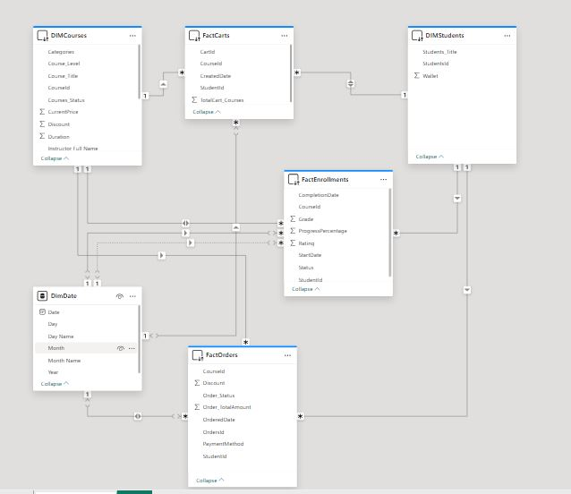

* DimCourses (course information)
* DimStudents (student data)
* FactEnrollments (enrollment and progress data)
* FactOrders (payment information)
* DimDate (date dimension)

The model follows a star schema design with fact tables connected to dimension tables for efficient analysis.

**Dashboard Features**

**1. Enrolled Courses Dashboard (Student ID: 9070)**

**Key Metrics:**

* Completed Courses: 4
* Free Courses: 2
* Average Grade: 87
* Total Enrolled Courses: 14

**Key Insights:**

* Course distribution by category shows Business as the dominant enrollment category
* Development courses rank second in popularity
* The subcategory breakdown shows DevOps as the most popular specialty (3 courses)
* Several niche categories (Web Design, Software Testing, etc.) have minimal enrollments (1 course each)

**Recommendations:**

* Focus on completing Business courses which form the largest portion of enrollments
* Consider exploring more DevOps courses as this appears to be an area of interest
* Diversify into other subcategories within Development to broaden skills

**2. Course Progress Dashboard (Student ID: 9070)**

**Key Metrics:**

* Overall Progress: 65.3%
* Average Course Rating: 4.0
* Learning Time Spent: 31.6 hours

**Key Insights:**

* Highest rated course is Kobildoo Japanese Facial Massage (4.5)
* Most time spent on Create and Sell Online Courses (9.0 hours)
* All courses show consistent ratings between 3.7-4.5
* Progress appears consistent across all courses (shown by orange line)

**Recommendations:**

* Complete the "Create and Sell Online Courses" which already has significant time investment
* Prioritize completing courses with higher ratings to maximize learning satisfaction
* Consider allocating more time to "Sales Skills Training" which has good ratings but moderate time investment

**3. Course Payments Dashboard (Student ID: 9070)**

**Key Metrics:**

* Completion Rate: 28.6%
* Total Savings: 2697.9 (currency not specified)
* Wallet Balance: 6519.1
* Total Spent on Courses: 2982

**Key Insights:**

* Most enrolled courses are at Beginner level (9 courses)
* Intermediate level shows 4 enrolled courses with 2 completed
* PayPal is the only payment method used (100%)
* The completion rate is relatively low at 28.6%

**Recommendations:**

* Focus on completing more beginner courses to improve the overall completion rate
* Consider utilizing the wallet balance for Advanced courses to build upon completed Beginner courses
* Diversify payment methods if other options become available for better account security

**Technical Implementation**

The solution architecture follows this flow:

1. SQL Server Database (Azure) → Contains all student and course data

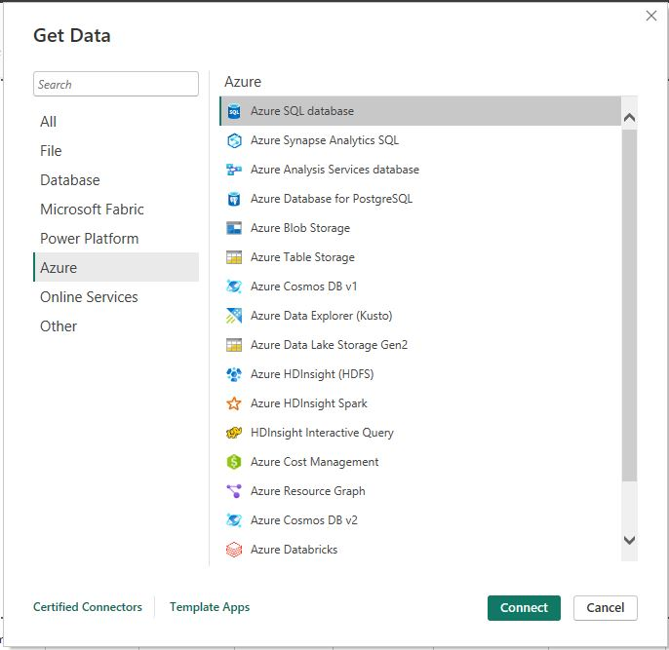

1. Power BI Semantic Model → Connects via DirectQuery for real-time data

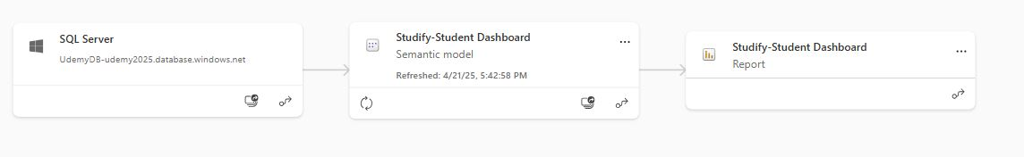

1. Power BI Reports → Created with user-specific visuals and parameters
2. Power BI Service → Hosts the published reports

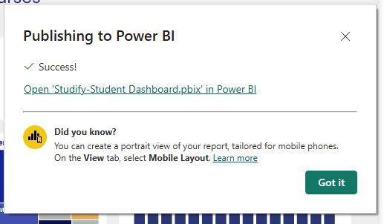

1. Studify Web Platform → Embeds dashboards with dynamic student ID filtering

**Dynamic Filtering Mechanism**

The dashboards implement dynamic filtering based on student ID:

1. When students access their profile page on Studify
2. The platform passes the student's unique ID (e.g., 9070) as a parameter to the embedded Power BI report
3. The report uses this parameter to filter all visuals to show only data relevant to that specific student
4. This creates a personalized experience where each student sees only their own courses, progress, and payment information

**User Experience**

Each student sees personalized dashboards in their profile that display their specific:

* Course enrollments and progress
* Payment history and spending patterns
* Time investment and learning analytics
* Course ratings and completion statistics

The demonstration dashboards in this documentation belong to Student ID 9070. The Power BI reports use row-level filtering to ensure that when a different student logs in, the dashboards automatically filter to show only that student's data. This personalization is achieved through parameter passing in the URL when the reports are embedded in the Studify platform, ensuring a customized analytics experience for each user.